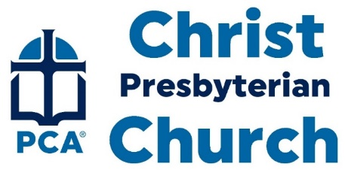
December 24, 2023
Welcome
Welcome to this service of worship. We invite you to slow down, quiet your heart, and to direct your thoughts to the living God.
Prelude:
First Lesson – John 1:1-13
¹ In the beginning was the Word, and the Word was with God, and the Word was God. ² He was with God in the beginning. ³ Through him all things were made; without him nothing was made that has been made. ⁴ In him was life, and that life was the light of all mankind. ⁵ The light shines in the darkness, and the darkness has not overcome it.
⁶ There was a man sent from God whose name was John. ⁷ He came as a witness to testify concerning that light, so that through him all might believe. ⁸ He himself was not the light; he came only as a witness to the light.
⁹ The true light that gives light to everyone was coming into the world. ¹⁰ He was in the world, and though the world was made through him, the world did not recognize him. ¹¹ He came to that which was his own, but his own did not receive him. ¹² Yet to all who did receive him, to those who believed in his name, he gave the right to become children of God— ¹³ children born not of natural descent, nor of human decision or a husband’s will, but born of God.
Hymn:

Prayer of Adoration
The Lord’s Prayer
All: Our Father, who art in heaven, hallowed be thy name. Thy kingdom come, thy will be done, on earth as it is in heaven. Give us this day our daily bread, and forgive us our debts as we forgive our debtors. And lead us not into temptation, but deliver us from evil. For thine is the kingdom, and the power, and the glory, forever and ever. Amen.
Hymn:
Second Lesson – John 1:14-18
¹⁴ The Word became flesh and made his dwelling among us. We have seen his glory, the glory of the one and only Son, who came from the Father, full of grace and truth.
¹⁵ (John testified concerning him. He cried out, saying, “This is the one I spoke about when I said, ‘He who comes after me has surpassed me because he was before me.’”) ¹⁶ Out of his fullness we have all received grace in place of grace already given. ¹⁷ For the law was given through Moses; grace and truth came through Jesus Christ. ¹⁸ No one has ever seen God, but the one and only Son, who is himself God and is in closest relationship with the Father, has made him known.
Hymn:
Prayer of Praise (Jessy Hurtado)
Children’s Recessional
Sermon – The Immanuel of Advent
Scripture Reading – Isaiah 7:14
Therefore the Lord himself will give you a sign. Behold, the virgin shall conceive and bear a son, and shall call his name Immanuel.
The Lord’s Table
Hymn:
Benediction
Announcements
- Diaconate/Mercy Ministry Conference, Saturday, March 16, 10-4pm, McLean Pres
- Nicaraguan Mission Trip, June 2-9, Questions? Ask Jim Crosely, hokiesub@yahoo.com
Greeting One Another

